T O S H I B A FIN Inclusion Matters

C O N T A C T S
Parents Supporting Parents with Child Safety

fi n q l d t s v @ g m a i l . c o m

- S S U E 3

- U N E 2 0 1 4

0 4 0 2 2 5 4 9 8 4

w w w . fi n -
q l d t s v . o r g . a u P O B o x 1 8 3 9
T o w n s v i l l e 4 8 1 0

1

I n s i d e t h i s
I ss u e
What is FIN Townsville?
It is now five years since the Family Inclusion Network Queensland (Townsville) began as an informal community organisation, and over three years since FIN Townsville became incorporated.

FIN Townsville Mission
To ensure parents, grandparents and significant others have access to the information, support and advocacy they require to actively and equitably par- ticipate in the child protection process.

FIN Townsville - a service user community organisation
FIN Townsville is n ot an organisation run only or mainly by professionals:
FIN is action by families, for families, with the help of resourceful friends – many of whom are social workers or social work students volunteering their time and resources
FIN is a form of community social work, currently without formal funding, but incorporated and registered as a Charity in Queensland.

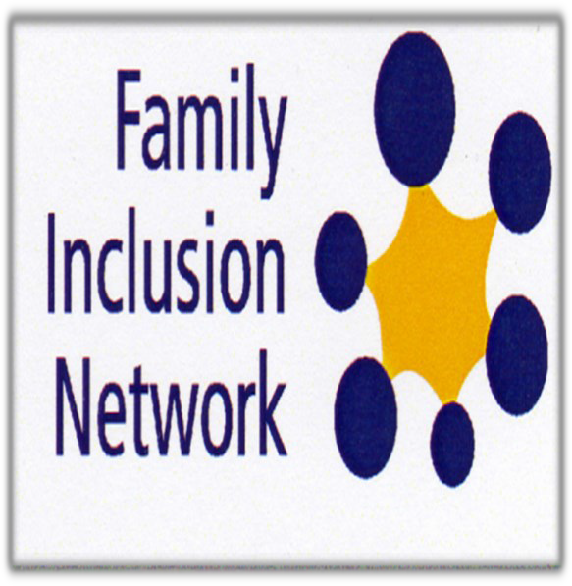cont. on Page 2
What Is FIN? What FIN does FIN Facts and Figures | 1  2  3
Relationship Work Practical Help | 4  5
Your Say  New develop- ments | 6  7
The Cord  Children’s Per- spectives | 8  9
It’s Up To Us  In the best inter- ests of the child | 10  11
FIN
Issue 3 Newsletter editors:
Wesley Bennet Ros Thorpe

———————————————————————————————————————————
Family Inclusion Network Townsville
Regular meetings
1st and 3rd Tuesday of each month from 10.30am until about 12.30pm at 431 Ross River Road, Cranbrook
Drop-in for support, information, friendship and morning tea

ISSUE 3 FIN Inclusion Matters PAGE 2

What FIN Townsville does
FIN resourceful friends support family members in meetings with the Queensland Child Safety Depart- ment and in the Children’s Court, and provide
informal family support (fostering families) to prevent (re)entry of children into care
FIN family members are centrally involved in the FIN Townsville committee which is active in undertaking systems advocacy
making submissions for changes in child protection policy and practice meeting with key ministers and bureaucrats
community and professional education

FIN support volunteers are
Resourceful Friends
Faithful Companions
Actively involved with Fostering Families
Co-workers with families to take action for social justice
Co-participants in FIN community development and community education

Qualities of supporters most valued by family members
Ask, don’t tell; Listen, don’t judge [title of 1st FIN DVD] Non–Judgement – respect, listening, walk in our shoes Knowledge and information
Support: Emotional support; Help with self-advocacy Practical help
Acceptance of reciprocated friendship and practical help

Outcomes
The FIN Townsville Resourceful Friends way of working has proved to be effective in
enhancing the resilience, wellbeing and empowerment of families involved with the child protection system
maintaining connections between children in care and their families
facilitating reunification of children with their families and preventing re-entry into care energising and inspiring social work professional volunteers.

What members say about FIN Townsville
They don’t set themselves up as experts, aren’t know-it-alls, don’t impose solutions, aren’t superior, don’t distance themselves from you. (Families’ group discussion, Sept 2013)

The most rewarding thing about working with FIN is learning about letting go of one’s power over people. I like the fact that in FIN professionals and volunteers work alongside parents as equals. (Jane, FIN professional volunteer, July 2013)

Source: presentation to be made at the World Social Work, Education and Development conference in Melbourne on 11th July 2014

For more detailed information and practice examples see:
Thorpe R and Ramsden K (2014) Resourceful Friends: upholding an invaluable dimen- sion in family inclusive child protection practice. Children Australia 39 (2)
See also the FIN Townsville website: www.fin-qldtsv.org.au

I S S U E 3
FIN Inclusion Matters
P A G E 3

FIN Facts and Figures presented at the FIN AGM November 2013
BBeettwweeeenn NNoovveemmbbeerr 22001122 ttoo NNoovveemmbbeerr 22001133 there were 33 new contacts1. This compares with 8 reported to the AGM in 2010, 11 reported in 2011, and 33 reported in 2012. In addition to supporting new contacts, FIN volunteers have continued to provide ongoing support to 10 parents/families from previous years. Thus, since November 2012 FIN Townsville has been supporting a total of 43 families. This is quite remarkable, since FIN Townsville has no paid workers and all support is given by committed volunteers.

TTwwoo tthhiirrddss ooff tthhee nneeww ccoonnttaaccttss were from single mothers, with a total of 30 contacts from parents and 3 from grandparents. Twenty came from the greater Townsville area and all but one of the remainder from else- where in Queensland, indicating a need for FINs to be developed around the state. The one exception was an in- quiry from Tasmania, underscoring the fact that the highest number of new contacts came as a result of people searching the internet and finding the FIN Townsville website.

Other important ssoouurrcceess ooff nneeww ccoonnttaaccttss were through FIN members and from contacts made by FIN sup- porters outside the Children’s Court. Additionally, in the last year, many more new contacts than in previous years had learned about FIN from various human services in Townsville. One was actually referred to FIN by the Depart- ment of Child Safety, as FIN was seen as able to work with an (understandably) angry father. Clearly, FIN Towns- ville is becoming better known in the local human services sector and is perceived, by some at least, as offering valuable support.

The most frequently cited iimmmmeeddiiaattee iissssuueess among new contacts concerned domestic and family violence, child sexual abuse (including what were experienced as false allegations), and parents or grandparents seeking help to negotiate improved contact arrangements with their children in care. The most frequent FIN responses to new contacts were to offer information and support over the phone and/or face-to-face support with parents at meetings with Child Safety personnel, together with emotional support and practical help - including houseclean- ing working bees to avert the removal of children into care, transport to meetings, and emergency assistance pending receipt of Centrelink benefits.

With parents/grandparents from previous years receiving oonnggooiinngg ssuuppppoorrtt most typically this was holistic per- sonal support, either with a view to helping families stay together following reunification, or sustaining others who live with chronic sorrow when their children remain in long term care. With this latter group support at meetings with the department was an important activity, while the former group tend to fear and avoid contact with the department.
Overall, one FIN parent has summed up what FIN offers as follows:
Knowledge and information – this is the ‘big one’ which FIN supporters give you: how the system works and how they can help you participate in it. They help you write letters; support you at meetings; help you develop contacts; they keep you informed, share information, join up the dots. (Sally, Sept 2013)
Additionally, many parents and grandparents have commented positively on how FIN volunteers do what they do, with a non-judgemental attitude being the most frequently mentioned highly valued quality. Sally spoke for all when she described the significance of not being judged as
helping you overcome the shame and embarrassment factor. You can talk more openly about shameful stuff with FIN supporters than with friends or family - or even with other professionals - because from them you fear judgement. Trust is very important.

- Detailed descriptive statistics can be found in Report on (1) new FIN contacts, (2) continuing support, (3) systems advocacy: November 2012 - November 2013, tabled at the 4th FIN Townsville AGM and available on request from finqldtsv@gmail.com

I S S U E 3
FIN Inclusion Matters

P A G E 4

Table 1 FIN Townsville Resourceful Friends – relationship work

Relationship work by Resourceful Friends | Relationship gifts from family members to FIN family and sup- porting members
Accepting people for who and what they are  Demonstrating true empathy, love and respect; hugs and physical comfort/ support  Making time to listen – without a form to fill in!  Listening to parents’ stories without judgement, with understanding and acceptance  Accepting contact from a family almost anytime (including evenings and weekends) but having honest & open discussions about constraints and time out for self-care  Being there at the time that something is happening; rallying around to help out a family in need.  Being reliable and dependable Going the extra mile  Working as a team – if one supporter can’t do something (eg provide sup- port at a meeting with Child Safety) the chances are another will step in  Ringing parents to make sure they are OK  Continually checking that the help offered is acceptable Devising plans together that everyone is happy with  Enabling parents to have choices and make their own decisions according to their own values  Role modelling acceptance Diffusing conflict  Not expecting anything in return but accepting reciprocation when it’s offered  Enjoying contact together; share fun | Friendship Feedback  New ideas and perspectives Warmth and positive regard Kindness  Hugs Acceptance Understanding Non-judgement

The Family Inclusion Network has been so helpful as they are a wealth of knowledge and were able to point out areas that had been mismanaged or simply incorrect. (Dimity, July 2013)
The fact that somebody is out there who understands what the problems are and what we are going through. And it’s good to meet professionals who know what support systems are available. (Tracey, July 2013)
You’re respected; someone cares; you’re valued; you’re not judged; you’re not dismissed as just a ‘piece of shit’ [i.e. labelled negatively as ‘a single parent’ or ‘involved with child safety’ and therefore automatically judged as ‘bad’ and ‘undeserving’]. (Sally, Sept 2013)
You meet other parents, this overcomes shame: you’re all in the same boat, have a shared connec- tion, develop bonds, build strength in yourself and in numbers. (Clare, Sept 2013)
The supporters are our friends - and they allow us to become their friends, unlike other human service workers. (Jack, Sept 2013)

I S S U E 3
FIN Inclusion Matters
P A G E 5

Table 2 Practical help – when somebody needs a helping hand

Practical help from FIN Resourceful Friends | Practical help from FIN family members to other families, supporting members and to the FIN or- ganisation
Transport  Caring for children when parents need a break; when parents go to work or are ill; taking children to & from school  Sewing clothes for children  Housecleaning when it all gets too much Garden clear-ups  Opening & sorting backlog of mail  Goods to help out when a family cannot afford them – eg bedding, clothing, meals, groceries, furniture, toilet paper  Loan of trailer to move furniture  Brokerage re other services eg furniture from Lifeline, food parcels  Loan of money, with pay back strategies  Gifts of money  Keeping money safe so that it’s not spent on eg smokes  Gifts of non-prescription pharmaceuticals eg inhaler, lip moisturiser, pain killers, cold and cough medi- cations  Use of washing machine when a family’s breaks down Shared use of equipment eg pressure cleaner, whipper  snipper  Loan of equipment eg video camera, TV  Open-house eg use of swimming pool, shared BBQs Emergency rent free accommodation in FIN house Removing rodents from the FIN house  Loan of camping equipment | Providing access to a house for FIN activities, including emergency accommodation for homeless FIN par- ents  Joint working bees for FIN house and garden; for other families’ houses at times of crisis;  Garage sales, fundraising BBQs  Handyperson tasks eg pressure cleaning, replace taps, hang pictures, clean ceiling fans and light shades, swimming pool maintainence  Car fixing tasks  Computer and printer fixing tasks  Babysitting and back-up care for sick/disabled family members  House cleaning  Informal contacts with tradespeople  Contacts with fundraising opportunities eg Rotary, Melville’s farm  Food handling training course  Gifts of eggs from backyard chooks  Skills re FIN projects eg making banners, filming and editing DVDs, creating and managing FIN website  Loan of equipment eg data projector Lending DVDs, books etc  Donation of second hand large office photocopier/ printer  Cook meals/cakes  Going camping together Having BBQ’s  Supportive friendship – texts, phone calls, visits, meeting for coffee

The listening ear comes into its own whilst you are doing the practical help together - not for people, but w i th people (Pip Pinhorn, community social worker, Sept 2013)
The supporters accept help from us and this makes us feel included, needed, worthy; you feel you have something to offer, you can give something back. (Tim, Sept 2013)
We work together as equals in fundraising activities, in working bees at the FIN house and in other families’ homes. And we have fun together. (Jack, Sept 2013)

I S S U E 3 ' FIN I f\11.a..tt:ws P A G E 6
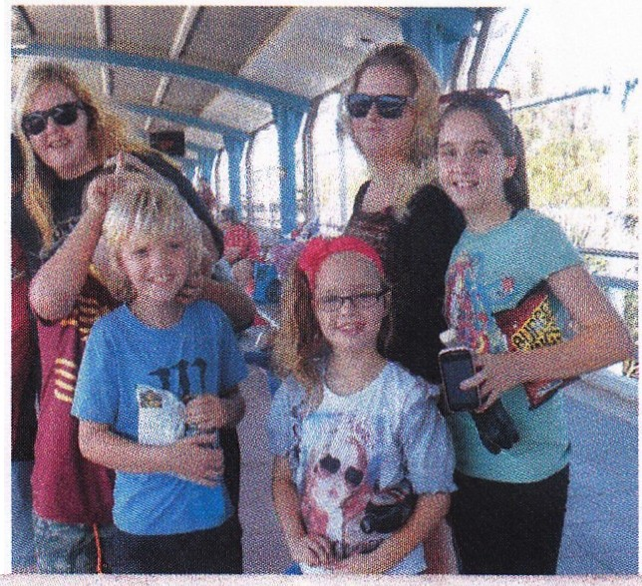YOU R SAY
I, Rachelle Henderson, give my consent for the photograph taken of me and my children at the railway station in Townsville to be used in the third issue of the FIN Townsville News- letter to illustrate a FIN success story for a happy family . \
28th April 2014
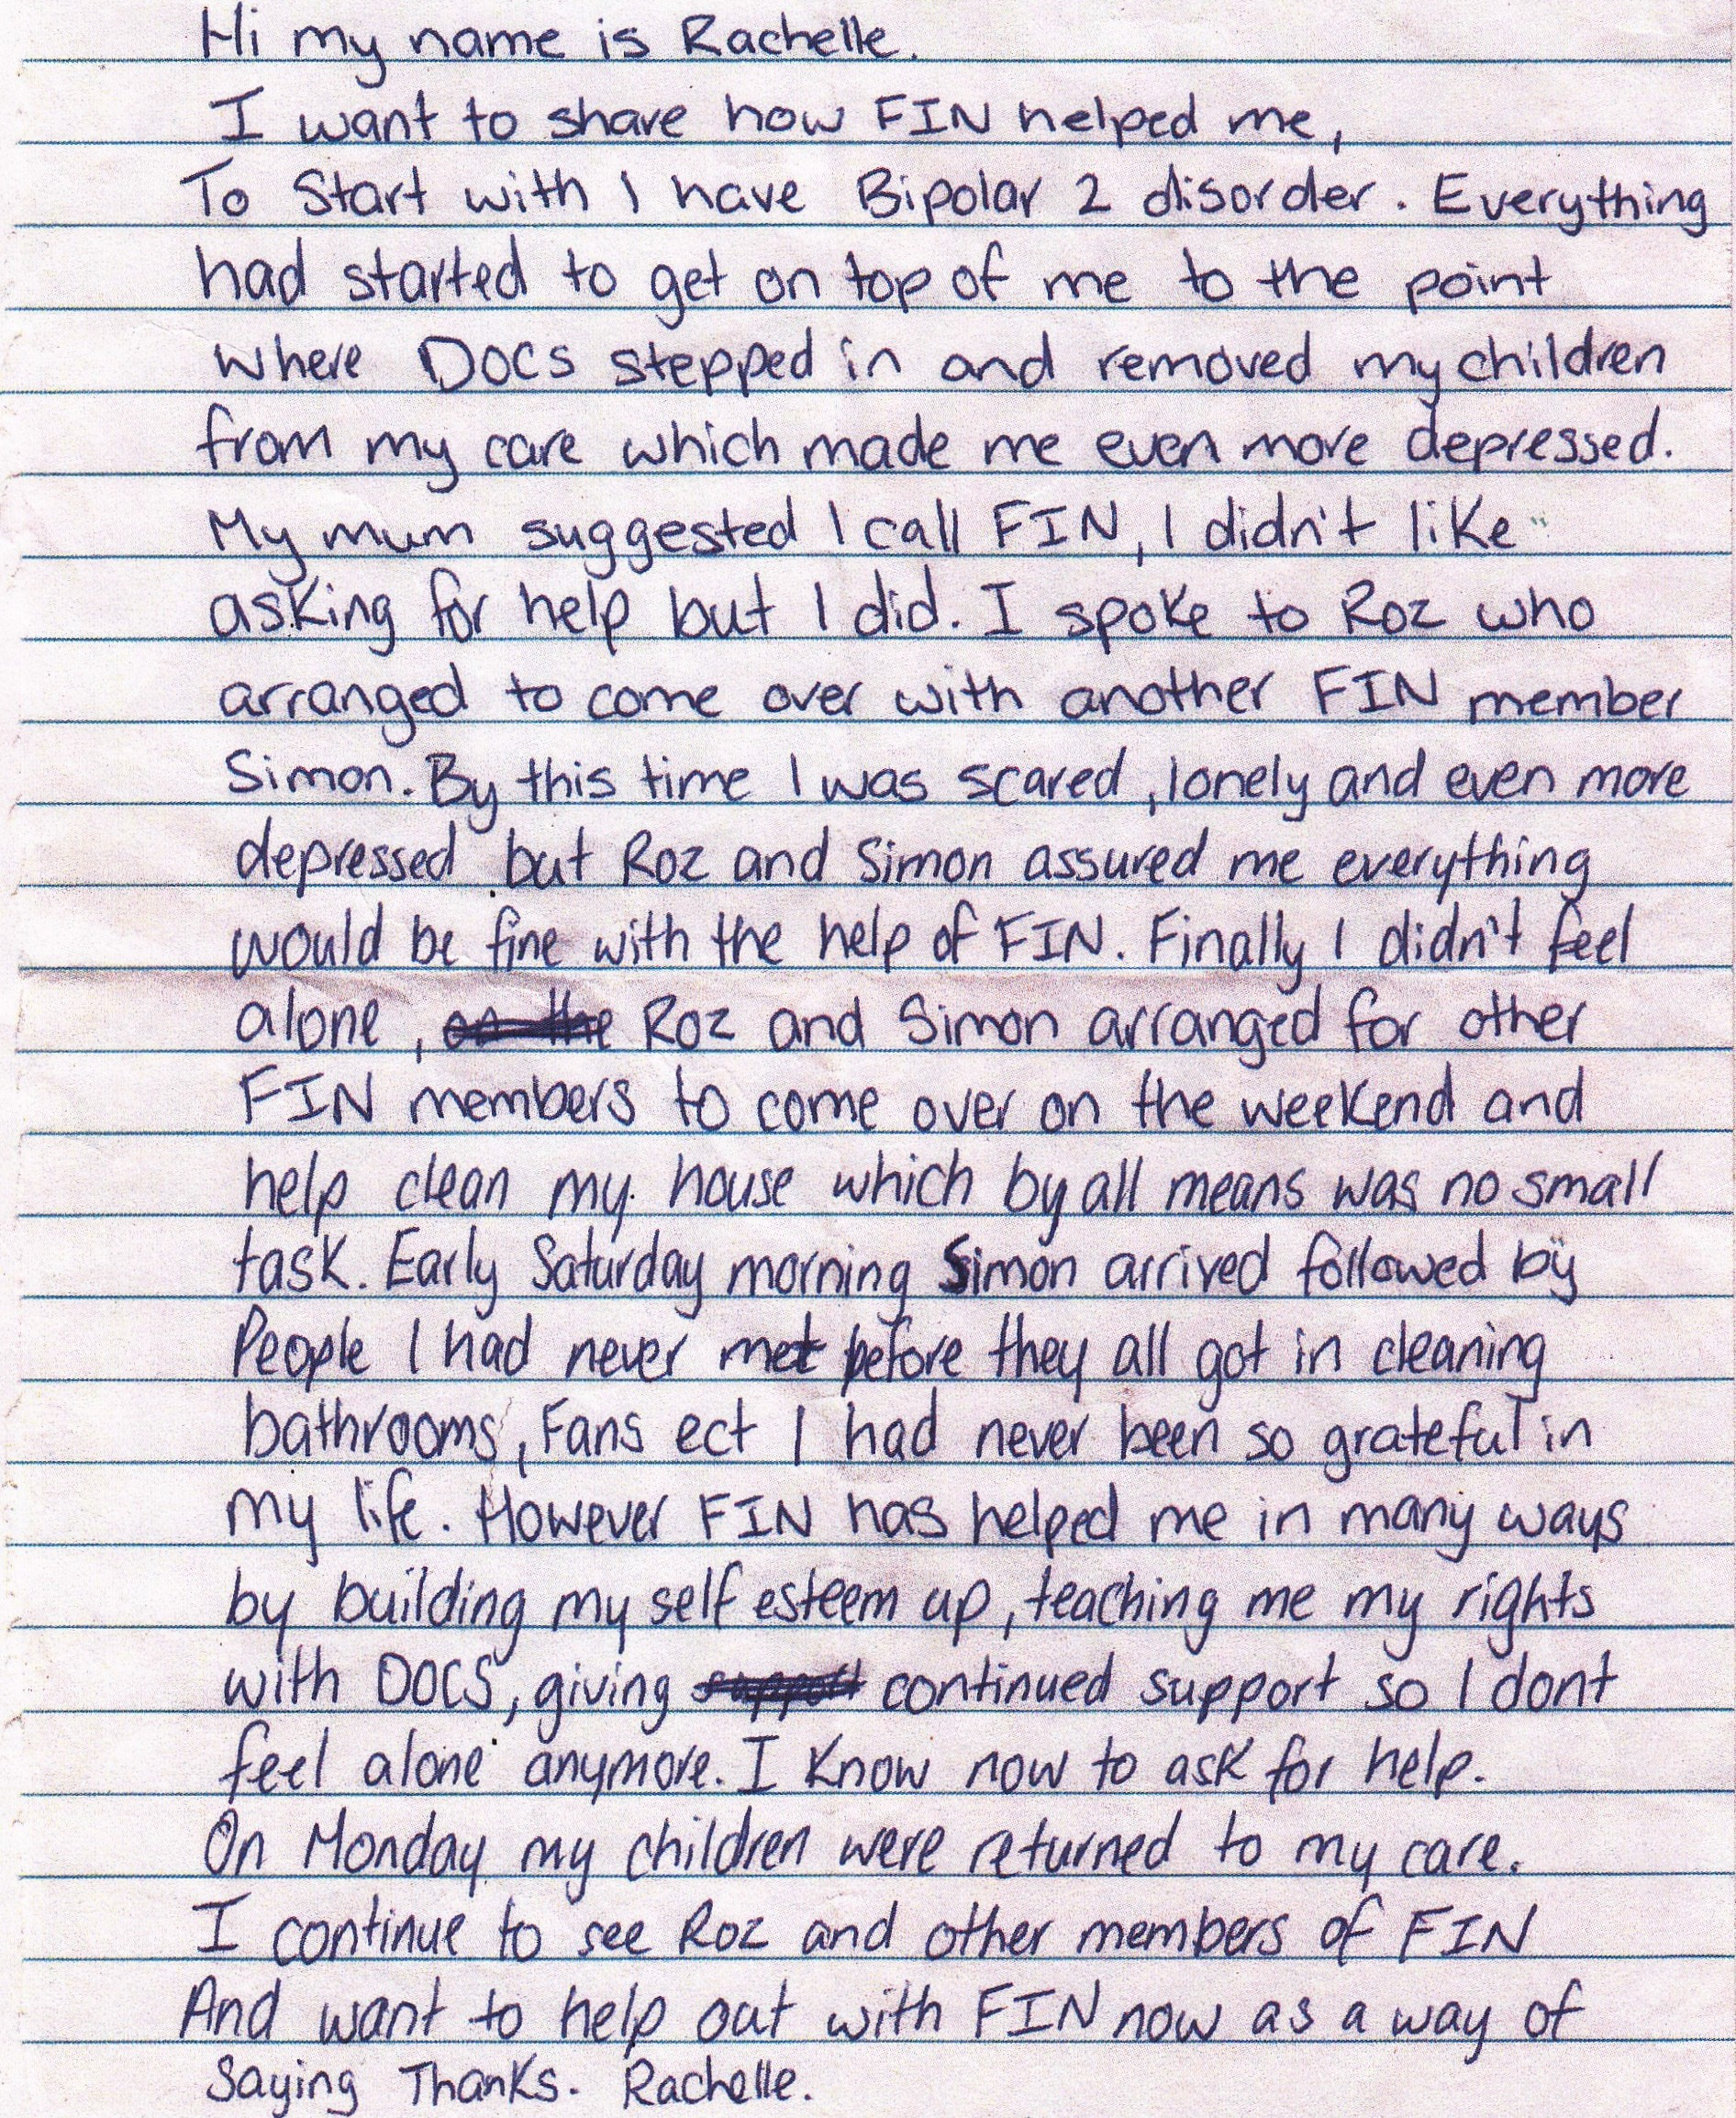l

••

ISSUE 3 FIN Inclusion Matters PAGE 7

Recent Developments in core FIN activities

Individual support and advocacy
In October 2013 FIN Townsville received a letter from a woman in the Townsville Correctional Centre asking for assistance in relation to her children in care of Child Safety. A reply was sent saying that three FIN committee members were applying for security clearance to visit women in the prison and that FIN would be willing to offer whatever assistance we could. It took about 6 weeks for Clearance and Induc- tion to be completed and in December 2013 a first visit was made during which a total of 6 women were seen. Word of mouth within the prison had reached many women who told us they found hope in hear- ing about the focus and work of FIN Townsville.
Since January 2014, 6 visits have been made to TWCC with a total of 15 women seen. Follow up phone calls to CSOs have been made and emails sent to the Regional Director of Child Safety on behalf of several of the women. Additionally, letters of support have been written for 2 women, and for another woman discussions have been held with a psychologist preparing a family report for Child Safety. On
one visit a woman was supported in her participation in a QCAT hearing by telephone. All of the women seen are deeply distressed by separation from their children and fear losing contact with them or even losing guardianship in the long term. Most are working towards turning their lives around with a view to regaining custody of their children after their release.
FIN is able to provide prisoners with understanding, support, information and advice about options. Foundation principles of respect for the dignity and worth of all persons are vitally important to FIN’s work in TWCC. In the second half of 2014 FIN plans to expand our work to the men’s prison.

Social Systems advocacy in the post Carmody era
One of the current aims of FIN Townsville is to ensure that the voices of families are heard—and heeded—in the implementation of the recommendations of the Carmody Inquiry, particularly in relation to prevention, family support, the new practice model and options for children and young people in care. To this end FIN Tsv has been proactive over the last 6 months in arranging meetings of groups of FIN Tsv family members and supporters with key people at both state and regional levels: (1) Matthew Lupi (Executive Director Child and Family Reform, Department of Communities, Child Safety, and Disability Services) and, (2) with Bill Hatton (Nth Qld Regional Director, Department of Communities et al) and Ni- cola Jeffers (Nth Qld Regional Director, Child Safety). These meetings have focussed on how the views and experiences of families, as to what works in supporting them to provide “good enough” care for
their children, can influence the design of new programs and practices.
In addition to these meetings the FIN Tsv president, Ros Thorpe, was invited to represent FIN Towns- ville on the Child and Family Reform Stakeholder Group. She attended the first meeting in Brisbane in February 2014 where she took every opportunity to give voice to the views of parents and grandparents caught up in the child protection system.
The Director General of the Department of Communities, Michael Hogan, is placing significant em- phasis on co-design and co–production in the reform planning and implementation process and FIN Tsv families and supporters are well placed to participate in consultation as the process unfolds.
This said, though, FIN Tsv is very well aware of the tyranny of distance and is actively lobbying for the inclusion of regional family voices in Head Office deliberations and policy formulation. These days there should be little impediment to this process, given ready access to video conferencing, skype, webinars etc. FIN Townsville would welcome your involvement in our discussions and we invite you to make con- tact via our email or hotline phone (see page 1 or page 10 for contact details), or you are very welcome to “drop-in” for morning tea on the first or 3rd Tuesday of each month (see page 1 for details).

ISSUE 3 FIN Inclusion Matters PAGE 8

In Remembrance of Annabelle Rose
17th February—5th March 2014

and
In support of Emma and Jamie—and all FIN parents and grand- parents who are separated from their children through death or being in care.

The Cord

You are connected, Your child and you, by An invisible cord
Not seen by the eye.

It's not like the cord
That connects you 'til birth This cord can't been seen By any on Earth.

This cord does its work Right from the start.
It binds you together Attached to your heart.

I know that it's there I know that it’s true The invisible cord
From your child to you.

The strength of this cord Is hard to describe.
It can't be destroyed It can't be denied.

It's stronger than any cord Man could create
It withstands the test Can hold any weight.

And though you are gone Though you're not here, The cord is still there
But no one can see.

It pulls at your heart
You are bruised … you are sore, But this cord is your lifeline
As never before.

Be thankful the cord Connects in this way
Parents, grandparents and child
Death or Child Safety can't take it away!

Author unknown http://angelsinflightinc.com/Memorial_Poetry.html

slight revisions made to the text.

I S S U E 3
FIN Inclusion Matters
P A G E 9

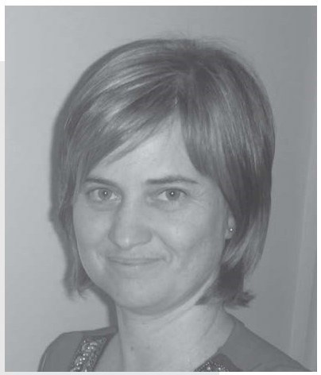
Extract from: developing practice Issue 36: Spring 2013 pp18-30
CHILDREN'S PERSPECTIVES ON THEIR OWN WELLBEING: "I DON'T THINK THEY CAN HEAR US."

BY KIM RAMSDEN
Department of Social Work and Human Services, James Cook University

and immediate past treasurer of FIN Townsville

INTRODUCTION
The wellbei ng of children has captured the attention of practitioners, theorists, policy-makers and researchers throughout history and across the globe. Whilst the best interests of children have been at the heart of this en- deavour, the construct of 'the best interests of the child' is ill-defined, has been subjectively enacted by professional adults, is subject to social change in attitudes and values, and children themselves have not always
been actively included in the decision-making processes considering their wellbeing.

Practice which acknowledges children's agency and recognises their capacity to provide insight into their own lived experience is developing. The past decade has witnessed a fundamental shift in how we understand children and their place in social and political life and such recognition has been accompanied by a growing interest in how children can be researched. Additionally, the notion that children can, and should, genuinely participate and have their views considered when decisions are made about their lives, has become an important principle in Australian policy. This paper considers the issue of children's genuine participation drawing firstly upon my social work practice and then on my current research project which critically examines 'the best inter- ests of the child' within statutory child protection practice. I acknowledge the generosity, cour- age and wisdom of Angel and Isabella (pseudonyms), whose participation enabled this paper to
be written. I t is my intention and hope that, through this writing, others can hear their voices and further consider the value of actively listening to children like them.
Whilst this article has focused primarily on the voice of the child, I acknowledge that best practice will also value, and include, parents and other significant people in the lives of these children. The United Nations highlights the importance of this in declaring that "the true measure of a nation's standing is how well it attends to its children - their health and safety, their material security, their education and socialization, and their sense of being loved, valued, and included in the families and societies into which they are born".
A further extract follows on page 10

ISSUE 3 FIN Inclusion Matters PAGE 10

CONCLUSION

The insight gained from my practice with Angel and pilot interview with Isabella provides a solid foundation on which to continue my research with children regarding their 'best interests'. Child aware approaches which promote the genuine participation
of children in decision-making enable their valuable contribution and hold significant promise in supporting the work of practitioners, theorists, policy-makers and research- ers involved in the child and family welfare field. The expanded understanding we gain from children's perspectives assist us in fulfilling our aims of promoting the safety and wellbeing of children.
Angel and Isabella's wisdom speaks for itself in demonstrati ng the capacity of young children to effectively communicate their ideas about their best interests, safety and wellbei ng. Both Angel and Isabella possessed the capacity and skill to form a working relationship with an adult practitioner and researcher respective-
ly in order to effectively share the reality of their lives.
Angel alerted us to her struggle to be heard, via the p lig ht of the baby ele- phant, whilst Isabella gave clear direction regarding looking children in the face and listening to what they have to tell us.
It is up to us whether we can hear them.
Angel and Isabella are pseudonyms

Extract from

Ramsden K (2013) Children’s Perspectives on their own well being. “I don’t think they can hear us”. developing practice Issue 36 pp 18-30

If you’d like to participate in Kim’s research see page 11 for information and contact details

FIN Townsville Committee 2014
President Ros Thorpe Secretary Giovanna Tama Treasurer Mark Dunstan
General Erin Rigby, Frank Reilly, Kylie Bennet, Wesley Bennet
If you would like to join and/or support FIN Townsville, please phone 0402 254 984 or write to finqldtsv@gmail.com
Or “drop-in” to one of our meetings on the 1st and 3rd Tuesdays of each month (see page 1 for details)
For more information check out the website: www.fin-qldtsv.org.au

As a charitable organisation we would welcome and value your support

I S S U E 3
Please detach this page and display to attract research participants Page 11

RESEARCH STUDY

EXPLORING SAFETY AND WELL-BEING WITH CHILDREN AND THEIR FAMILIES WHO HAVE BEEN INVOLVED WITH THE QUEENSLAND DEPARTMENT OF CHILD SAFETY
WHAT IS: In the best interests of the child ?
Decisions about children’s safety and wellbeing are made by the Queensland Department of Child Safety. These decisions are based on ‘the best interests of the child’ yet there is no agreement about what these ‘best interests’ are.

The rights of children and families to participate in matters which affect them is central to this study and invites you to share your own ideas about what ‘the best interests’ mean to you.

I am very interested to hear about the ideas that children and young people have about what is best for themselves and what they think about safety and wellbeing.

I am also very interested in the ideas that parents and other family members have about the safety, wellbeing and best interests of the children and young people in their family.

IF YOUR FAMILY HAS BEEN INVOLVED WITH THE QUEENSLAND DEPARTMENT OF CHILD SAFETY in the PAST YOU ARE WARMLY INVITED TO PARTICIPATE.
J A M E S C O O K U N I V E R S I T Y
PhD research student Kim Ramsden

Phone: 0400231572
E-mail: kim.ramsden@jcu.edu.au

Kim Ramsden Phone: 0400231572  E-mail: kim.ramsden@jcu.edu.au | Kim Ramsden Phone: 0400231572  E-mail: kim.ramsden@jcu.edu.au | E-mail: kim.ramsden@jcu.edu.au

This research invites children aged 4-14 years AND adult family members including
parents, aunts, uncles, cousins and grandparents. ADULTS who as children were involved with the Department are also invited.

It is hoped that the knowledge shared in this research will be used to inform child and family welfare practice
Kim Ramsden Phone: 0400231572
E-mail: kim.ramsden@jcu.edu.au
Kim Ramsden Phone: 0400231572
E-mail: kim.ramsden@jcu.edu.au
Kim Ramsden Phone: 0400231572
E-mail: kim.ramsden@jcu.edu.au
Kim Ramsden Phone: 0400231572
E-mail: kim.ramsden@jcu.edu.au
Kim Ramsden Phone: 0400231572
E-mail: kim.ramsden@jcu.edu.au
Kim Ramsden Phone: 0400231572
E-mail: kim.ramsden@jcu.edu.au
Kim Ramsden Phone: 0400231572

